NHS Athletic Booster Club
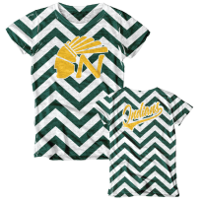
Spirit Wear Order Form
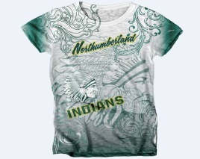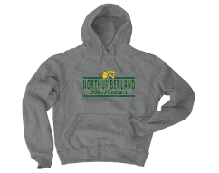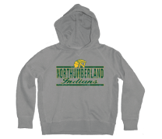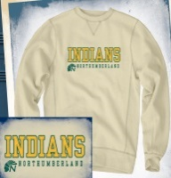
WOMEN’S  T-Shirt  (Chevron)  $20 |  | WOMEN’S  T-Shirt  (Retro Indian)  $20 |  | MEN’S  Tri-Blend T-Shirt  (Heather Gray)  $17 |  | ADULT  Soft Sanded Fleece Hoodie  (Gunmetal)  $35 |  | YOUTH  T-Shirt  (Heather Gray)  $15 |  | YOUTH  Soft Sanded  Fleece Hoodie  (Heather Gray)  $25 |  | ADULT  Applique  Crewneck Sweatshirt  (Bone)  $40
Size | Qty | Size | Qty | Size | Qty | Size | Qty | Size | Qty | Size | Qty | Size | Qty
Small |  | Small |  | Small |  | Small |  | XSmall (4) |  | XSmall (4) |  | Small
Medium |  | Medium |  | Medium |  | Medium |  | Small (6-8) |  | Small (6-8) |  | Medium
Large |  | Large |  | Large |  | Large |  | Medium (10-12) |  | Medium (10-12) |  | Large
Xlarge |  | Xlarge |  | Xlarge |  | Xlarge |  | Large (14-16) |  | Large (14-16) |  | Xlarge
2 XL $2 more |  | 2 XL $2 more |  | 2 XL $2 more |  | 2 XL $2 more |  | XL (18-20) |  |  |  | 2 XL $2 more
TOTAL=  $ |  | TOTAL=  $ |  | TOTAL=  $ |  | TOTAL=  $ |  | TOTAL=  $ |  | TOTAL=  $ |  | TOTAL=  $

Name: ________________________ Contact Number: _________________ Total Due: ____________

Please make checks payable to NHS Athletic Booster Club
Questions? Contact Yvonne Woolard, NMS @ 804-580-5753

